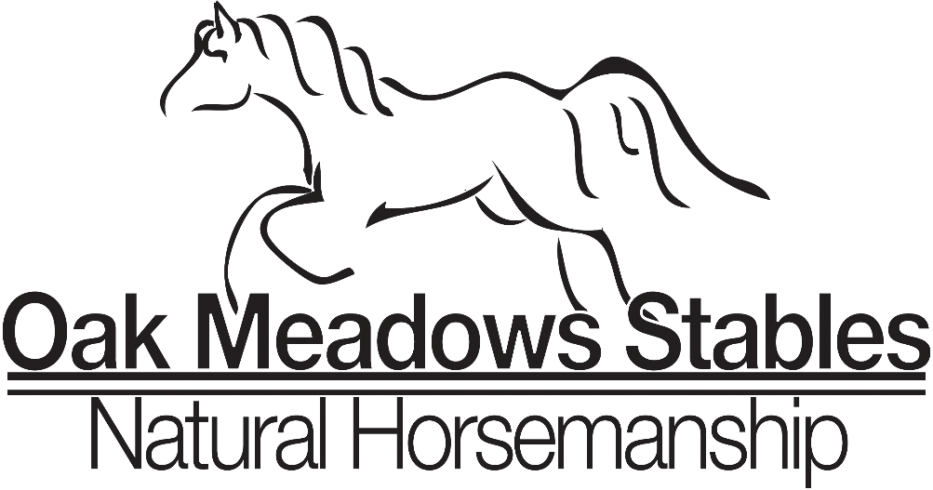 Riding Lesson Contract 2022
DATE__________________
RIDER_________________________RIDER’s GUARDIAN_____________________
Horsemanship lessons are telling the whole story of the horse and rider
This is a contract between above rider and Oak Meadows Stables and the above rider. Riding lessons are to be paid on the first lesson of each month, minimum of 4 lessons paid in full. Some months will have a fifth weekday four times a year these will be paid as attended or used as make up lessons. Group lessons are $45. Per lesson. Private lessons are $70. Monthly group lessons are $180 with extra lesson week at regular price. Monthly private lessons are $280. Please contact Oak Meadows Stables if any other payment arrangement needs to be made. Lessons are one hour and 30 minutes. We will make every attempt to start on time and end on time. If you arrive late for your lessons the time will not be adjusted. The only condition for extending the lesson time is if the riding instructor is not available to start on time due to the random needs of the horses.
At any time when a rider does not show up for their lesson they will be required to pay for that lesson unless at least 4 hours’ notice is given by text. When students don’t show up for the lesson they may not realize that instructors have set aside that time and planning for the lessons, horses have to be fed and shod and much preparation has occurred. If we need to cancel or reschedule a lesson due to inclement weather conditions, usually storms with lightning, or severe weather alerts we will notify parents the day of the class. If you aren’t sure please call Miss Leah or Lydia Powell for the details by 1:00pm that day. Your space is reserved in our class and advancing your horsemanship means attending all classes so that your skills progress as your understanding of the horse and rider bonds of Companionship and communication develop. Your support helps us continue to care for our school horses and provide a safe environment for learning. Thank you for your understanding and respect for the work we do and the information we share about our wonderful school horses. Our goal is to provide you with the best learning environment with a deeper level of savvy and understanding about these beautiful intelligent animals.
Miss Leah 256-783-7695 Miss Lydia Powell 256-529-7538 Initial _________
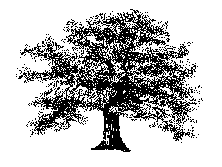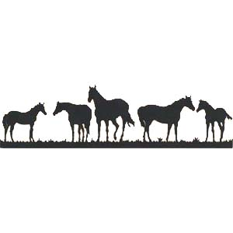
While sharing and caring for horses, we discover ourselves
We at Oak Meadows understand that safety is a priority and that proper clothing that protects from the elements. During our hot summers, lightweight stretchy jeans, capris, or shorts that reach the knee are fine. While in the winter we need to have several layers top and bottom. Roomy clothes but not silky or slippery fabrics. Gloves are a must in the cold and scarfs are recommended. Sunglasses or sun screen helps in bright light. We also require a boot that protects the ankle, has a smooth sole, and no more than a ½ inch heel. We recommend you not overspend on boots that will be outgrown quickly. Many fashion boots are modeled after paddock and riding boots. Look online and we will also help you find a pair that fits well. Helmets are required and we have many helmets we provide but others can use them and they may have to be readjusted often. A personal helmet is a great inexpensive birthday or Christmas gift and has a more custom fit for the adult or child.
I understand that it is the riders’ responsibility prior to entering the lesson area to inform the instructor of any new medical or physical problems which may impact their safety or ability to perform correctly during their scheduled riding lesson. Many children come directly from school and we ask parents to provide a snack and beverage before the lesson starts. Grooming, groundwork, saddling, and riding are all strenuous and require a well hydrated and comfortable person to have the best possible lesson.
A Horsemanship Lesson is 90 minutes in length and is to consist of grooming, saddling, mounting each rider and tack adjustments. The riding instructor additionally has the responsibility of safety of all riders, volunteers, and horses at all times so therefore, the instructor has the right to deviate from the lesson outline when safety is a concern. Occasionally we will have a lesson based totally on safety and groundwork. These are the most important skills we can pass on. A rainy day in the indoor arena are perfect for these lessons.
I the undersigned have read and understand the above contract plus all the Oak Meadows Policies and rules which I agree to abide by in full. I have received a copy of this contract which includes the Oak Meadows Stables policies and rules. I further understand that if any of the Oak Meadows Stables policies and rules are not followed Oak Meadows Stables has the right to cancel this contract in full without any refund of moneys remaining for this session.

ACCEPTED BY: Riders signature______________________________________________
Parent/Guardian of minor rider__________________________________
RELEASE OF LIABILITY

Rider______________________________ Date____________________________

WITNESS THIS AGREEMENT this ______ day of _________________, 20___, by and between Leah Imsand, Oak Meadows Stables, hereinafter referred to as MANAGER and _______________________, hereinafter referred to as RIDER, and, if Rider is a minor, Rider's parent or guardian, ____________________________________. In consideration received, and in return for the use, today and on all future dates of the property, facilities and services of Manager, Manager's instructors, employees and agents; Rider, Rider's heirs, assigns, and representatives, hereby agree as follows:
1. Inherent Risks and Assumption of Risk. The undersigned acknowledges there are inherent risks associated with equine activities such as described below, and hereby expressly assumes all risks associated with participating in such activities. The inherent risks include, but are not limited to the propensity of equines to behave in ways such as, running, bucking, biting, kicking, shying, stumbling, rearing, falling or stepping on, that may result in an injury, harm or death to persons on or around them; the unpredictability of equine’s reaction to such things as sounds, sudden movement and unfamiliar objects, persons or other animals; certain hazards such as surface and subsurface conditions; collisions with other animals; the limited availability of emergency medical care; and the potential of a participant to act in a negligent manner that may contribute to injury to the participant or others, such as failing to maintain control over the animal or not acting within such participant’s ability. Initial__________

2. Rider acknowledges that horses, by their very nature are unpredictable and subject to animal whim, which may include behavior including but not limited to their propensity to kick, bite, shy, buck, stumble, bolt, rear or general unpredictability. Rider assumes all risks in connection therewith, and expressly waives any claims for any injury or loss arising therefrom. Rider agrees to abide by and follow Manager's rules and regulations which, shall be posted and /or available from time to time. Rider further acknowledges that the behavior of any animal is contingent to some extent upon the ability of Rider. Rider assumes all risks therefor and warrants a full and fair disclosure of Rider's abilities has been made to Manager. Initial______

3. Rider expressly releases Manager from any and all claims for personal
injury or property damage, even if caused by negligence (if allowed by the laws of this State) by Manager or its representatives, agents or employees. Initial________

WARNING
Under Alabama law, an equine activity sponsor or equine professional is not liable for an injury to or the death of a participant in equine activities resulting from the inherent risks of equine activities, pursuant to the Equine Activities Liability Protection Act. Initial_______

4. RIDER (OR RIDER’S PARENT OR GUARDIAN) AGREES TO HOLD HARMLESS, INDEMNIFY AND DEFEND MANAGER AGAINST ANY AND ALL CLAIMS, DEMANDS, CAUSES OF ACTION, DAMAGES, JUDGMENTS, ORDERS, COSTS OR EXPENSES, INCLUDING ATTORNEY'S FEES, WHICH MAY IN ANY WAY ARISE FROM OR BE IN ANY WAY CONNECTED WITH RIDER'S USE OF OR PRESENCE UPON THE PROPERTY OF MANAGER AND THE FACILITIES LOCATED THEREON. In the event rider is a minor, the parent or guardian shall further indemnify, defend and hold Manager harmless from any such claims by said minor child, regardless of any statute of limitations or contractual limitation of actions. Initial_______

5. In the event Rider is using Rider's own horse, or a horse(s) not owned by Manager, Rider warrants said horse(s) shall be free from infection, contagious or transmittable diseases. Manager reserves the right to refuse access or use of any horse upon the premises that does not appear to Manager to be in good health, or is deemed dangerous or undesirable. Initial_______

6. Any action brought under this agreement shall be brought within one (1) year of the incident or accident giving rise to said claim. Rider agrees that damages shall be limited to $250 for property damage, medical or other actual expenses incurred, and a maximum of $10,000 for damages such as pain and suffering. Initial_______

7. Rider agrees to waive the protection of any applicable statutes in this jurisdiction whose purpose, substance and/or effect is to provide that a general release shall not extend to claims, material or otherwise, which the person giving the release does not know or suspect to exist at the time of executing said release. Initial_______

Rider's Signature_______________________ Manager OMS_________________________

Parent or Guardian if Rider is a Minor____________________________________________

Student Information

Name: __________________________________ Age: _________________
Address:__________________________________________________________
Street City State ZIP
Cell Phone: ___________________________ Birthday: ____________

FAMILY: (please complete only if student is a minor child)

Mother:
Name: _______________________________ Email: _____________________________

Employer:_________________________ Work Phone: ____________________________

Cell Phone:__________________________ Home Phone: __________________________

Father:
Name: _______________________________ Email: _____________________________

Employer:____________________________ Work Phone:_________________________

Home Phone: __________________________ Cell Phone:__________________________

Case of an Emergency, Please Notify:
Name: _______________________________ Relationship to child: __________________ Phone: ______________________________
Medical Insurance:
Company: ____________________________ Policy Number: _______________________
Notes or Special Circumstances: Please list any special circumstances or conditions that affect your child and that should be brought to the attention of the instructors. If your child suffers from a chronic medical condition, please explain and give any medication instructions.
Oak Meadows Stables Covid 19 Waiver/Release
WAIVER/RELEASE FOR COMMUNICABLE DISEASES INCLUDING COVID-19
ASSUMPTION OF RISK / WAIVER OF LIABILITY / INDEMNIFICATION AGREEMENT In consideration of being allowed to participate on behalf of Oak Meadows Stables program and related events and activities, the undersigned acknowledges, appreciates, and agrees that:
- Participation includes possible exposure to and illness from infectious diseases including but not limited to MRSA, influenza, and COVID-19. While particular rules and personal discipline may reduce this risk, the risk of serious illness and death does exist; and,
- I KNOWINGLY AND FREELY ASSUME ALL SUCH RISKS, both known and unknown, EVEN IF ARISING FROM THE NEGLIGENCE OF THE RELEASEES or others, and assume full responsibility for my participation; and,
- I willingly agree to comply with the stated and customary terms and conditions for participation as regards protection against infectious diseases. If, however, I observe any unusual or significant hazard during my presence or participation, I will remove myself from participation and bring such to the attention of the nearest official immediately; and,
- I, for myself and on behalf of my heirs, assigns, personal representatives and next of kin, HEREBY RELEASE AND HOLD HARMLESS (Oak Meadows Stables) their officers, officials, agents, and/or employees, other participants, sponsoring agencies, sponsors, advertisers, and if applicable, owners and lessors of premises used to conduct the event (“RELEASEES”), WITH RESPECT TO ANY AND ALL ILLNESS, DISABILITY, DEATH, or loss or damage to person or property, WHETHER ARISING FROM THE NEGLIGENCE OF RELEASEES OR OTHERWISE, to the fullest extent permitted by law.

I HAVE READ THIS RELEASE OF LIABILITY AND ASSUMPTION OF RISK AGREEMENT, FULLY UNDERSTAND ITS TERMS, UNDERSTAND THAT I HAVE GIVEN UP SUBSTANTIAL RIGHTS BY SIGNING IT, AND SIGN IF FREELY AND VOLUNTARILY WITHOUT ANY INDUCEMENT.
Name of participant: ___________________________
Participant signature: _____________________________
Date signed: ____________________
FOR PARTICIPANTS OF MINORITY AGE (UNDER AGE 18 AT THE TIME OF REGISTRATION)
This is to certify that I, as parent/guardian, with legal responsibility for this participant, have read and explained the provisions in this waiver/release to my child/ward including the risks of presence and participation and his/her personal responsibilities for adhering to the rules and regulations for protection against communicable diseases. Furthermore, my child/ward understands and accepts these risks and responsibilities. I for myself, my spouse, and child/ward do consent and agree to his/her release provided above for all the Releasees and myself, my spouse, and child/ward do release and agree to indemnify and hold harmless the Releasees for any and all liabilities incident to my minor child’s/ward’s presence or participation in these activities as provided above, EVEN IF ARISING FROM THEIR NEGLIGENCE, to the fullest extent provided by law.
Name of parent/guardian: ______________________
Parent guardian signature: ______________________ Date: ________________
Oak Meadows Stables Covid 19 Guidelines 2-18-2022
Due to the rise in cases of Covid 19 in Alabama recently, we have decided for the safety of ourselves and clients to adjust our operating procedures until further notice.
- No student will be permitted to attend camp or lessons if they have traveled outside of Madison county or have been to largely populated areas/events in the last 10 days. Every effort will be made to reschedule, if not possible a refund will be given.
- All social distancing will be advised, except when assisting a student requires closer contact. All persons who have not been vaccinated will be asked to wear a mask. The wearing of a mask will be strongly recommended. We will leave compliance to wearing a mask to each individual.
- We ask that parents remain in their vehicles. If you want to watch your child’s lesson please respect our social distancing policy.
- Please do your part by staying home if you have any concerns of exposure or are experiencing any symptoms.

Very respectfully,
Miss Leah

