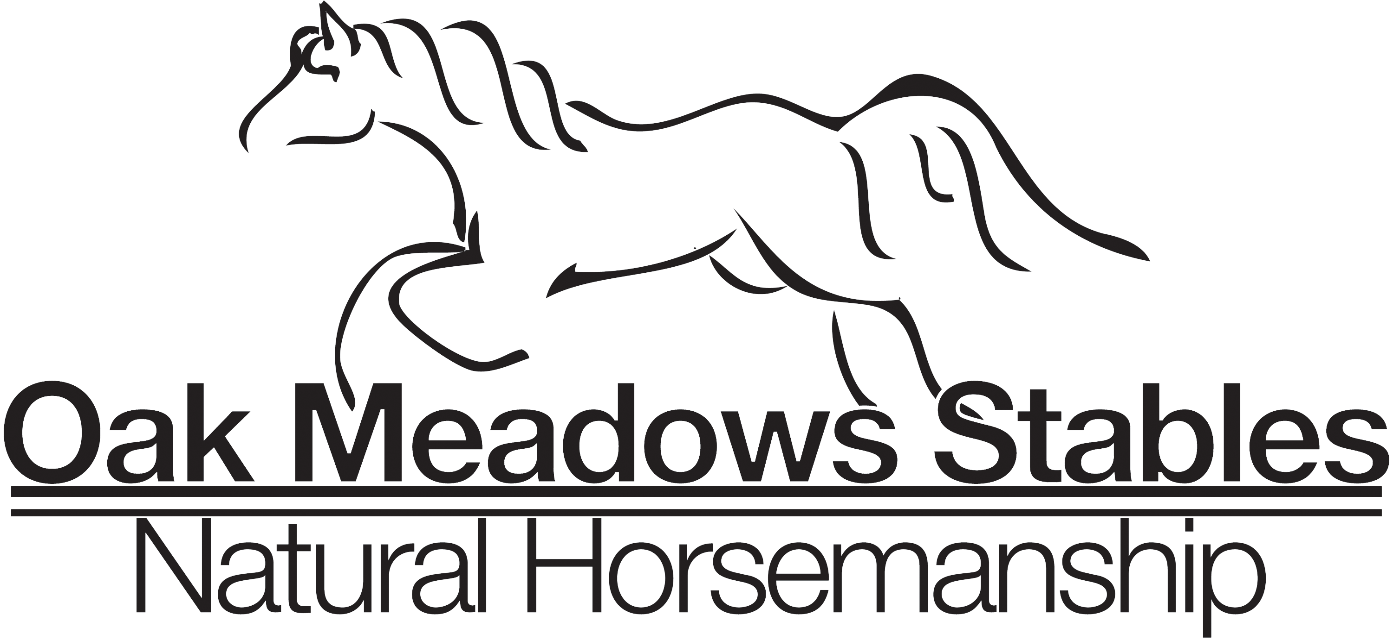
BOARDING STABLE AGREEMENT 2023

WITNESS THIS AGREEMENT this ______ day of _____________, 20__, by and between Oak Meadows Stables, hereinafter referred to as "Stable," and the individual or individuals undersigned, hereinafter referred to as "Owner."

Fees, Term, and Location. Owner acknowledges and accepts those terms set forth in the rate schedule applicable on the date above as issued by Stable, whether said rates be daily, weekly, or monthly. Payment shall be issued in accordance with that rate schedule on a timely basis. Any charges not paid in a timely manner shall be subject to finance charges set forth in the rate schedule. In the event the subject animal is removed from the premises for any reason and returned, this agreement shall be deemed reinstated at rates applicable at the time of said return. Stable reserves the right to notify Owner within fifteen (15) days of the horse's arrival if the horse, in Stable's opinion is deemed to be dangerous or undesirable for Stable's establishment. In such case, Owner shall be solely responsible for removing the horse within seven (7) days of said notice and for all fees incurred during the horse's presence upon the premises. This Contract shall be deemed terminated and concluded upon the payment of all fees.
1.. The boarding fee is due upon the first of the preceding month unless alternative date is recognized by both parties. In the event said payment is overdue by five (5) days, a late fee of $25 will be imposed with $5 added each day till board is paid. If board is not paid for three months stable shall be entitled to exert a lien against said horse, and the property upon the premises as more further described below, for any amounts due, and shall be entitled to enforce said lien and foreclose its interest against said horse and/or equipment for the amount due in accordance with the laws of the State of Alabama. A security deposit of $100.00 payable with this Contract to hold stall till horse arrives, shall be subtracted from first month board. The initial monthly charge applicable to the services as set forth below shall be $500 per month. Pasture board rate: $325 per month.

2. Description of Horse(s) to be Boarded. Owner agrees to submit a fully complete Owner Information Sheet for each horse boarded upon execution of this agreement. The terms and conditions set forth herein shall be applicable to each and every animal boarded by Owner.

3. Feed, Facilities, and Services. Stable agrees to provide adequate feed and facilities for normal and reasonable care required to maintain the health and well-being of the animals. Owner acknowledges Owner has inspected the facilities and finds same in safe and proper order. The standard services to be provided herein and the charges therefor are as posted in the office of Stable and are subject to change at Stable's discretion.

4. Risk of Loss and Standard of Care. DURING THE TIME THAT THE HORSE(S) IS/ARE IN CUSTODY OF STABLE, STABLE SHALL NOT BE LIABLE FOR ANY SICKNESS, DISEASE, ESTRAY, THEFT, DEATH OR INJURY WHICH MAY BE SUFFERED BY THE HORSE(S) OR ANY OTHER CAUSE OF ACTION, WHATSOEVER, ARISING OUT OF OR BEING CONNECTED IN ANY WAY WITH THE BOARDING OF SAID HORSE(S), EXCEPT IN THE EVENT OF NEGLIGENCE ON THE PART OF STABLE, ITS AGENTS, AND/OR EMPLOYEES. This includes, but is not limited to, any personal injury or disability the horse Owner, or Owner's guest, may receive on Stable's premises.

The Owner fully understands that Stable does not carry any insurance on any horse(s) not owned by it for boarding or for any other purposes, whether public liability, accidental injury, theft or equine mortality insurance, and that all risks connected with boarding or for any other reason for which the horse(s) in the possession of, and on the premises of Stable are to be borne by the Owner. Stable strongly recommends equine mortality insurance be obtained applicable to the subject horse(s) by Owner.

THE STANDARD OF CARE APPLICABLE TO STABLE IS THAT OF ORDINARY CARE OF A PRUDENT HORSE OWNER.

5. Hold Harmless. Owner agrees to hold Stable harmless from any and all claims arising from damage or injury caused by owner’s horse(s) to anyone, and defend Stable from any such claims. Owner agrees to disclose any and all hazardous or dangerous propensities of horse(s) boarded with Stable.

6. Emergency Care. Stable agrees to attempt to contact Owner should Stable feel that medical treatment is needed for said horse(s), but, if Stable is unable to contact Owner, Stable is then authorized to secure emergency, veterinary, and blacksmith care required for the health and well-being of said horse(s). All costs of such care secured shall be paid by Owner within fifteen (15) days from the date Owner receives notice thereof, or Stable is authorized, as Owner's agent, to arrange direct billing to Owner.

STABLE SHALL ASSUME THAT OWNER DESIRES SURGICAL CARE IF RECOMMENDED BY A VETERINARIAN IN THE EVENT OF COLIC, OR OTHER LIFE-THREATENING ILLNESS, UNLESS STABLE IS INSTRUCTED HEREIN OR ON OWNER'S INFORMATION SHEETS, BY OWNER THAT THE HORSE(S) IS/ARE NOT SURGICAL CANDIDATES. Initial _________

Owner agrees to notify Stable of any and all change of addresses, emergency telephone numbers, itineraries or other information reasonably necessary to contact Owner in the event of an emergency. In the event Owner departs for vacation or is otherwise unavailable, prior to departure Owner shall notify Stable as to what party is authorized to make decisions in the Owner's place with regard to the health, well-being, and/or medical treatment of the horse(s).

7. Limitation of Actions. Any action or claim brought by Owner against Stable for breach of this Contract or for loss due to negligence must be brought within one (1) year of the date such claim or loss occurs.

8. Shoeing and deworming. Owner agrees to provide the necessary shoeing and deworming of the horse(s) as is reasonably necessary, at Owner's expense. Owner agrees to provide Stable with all health records with regard to the horse(s). Owner agrees to have the horse(s) wormed and vaccinated on a regular schedule, and in the event same is not accomplished and proof of same presented to Stable within thirty (30) days from the date of such services or veterinary treatment, Stable is authorized to arrange for such treatment, but not obligated to do so; such expense shall be the obligation of Owner, and upon presentation by Stable of the bill for such services rendered, including service charges, any bill shall be paid within fifteen (15) days from the date the bill is submitted to the Owner.

9. Ownership-Coggins Test. Owner warrants that he owns the horse(s) and will provide proof satisfactory to Stable of the negative Coggins test upon request.

10. Changes or Termination of This Agreement. It is agreed by the parties that this Agreement may be changed or terminated upon thirty (30) days notice, regardless of the rental period. All notices must be issued in writing unless otherwise agreed upon by the parties. The posting of updated rate schedules in a conspicuous or open place in Stable's office shall constitute notice of any and all rate changes or regulation changes as may be deemed appropriate by Stable.

11. Rules and Regulations. The Owner agrees to abide by all the rules and regulations of the Stable. In the event someone other than the Owner shall call for the horse(s), such person shall have written authority signed by the Owner to obtain said horse(s).

12. Right of Lien. The Owner is put on notice that Stable has a right of lien as set forth in the laws of the State of Alabama, for the amount due for the board and keep of such horse(s), and also for storage and services, and shall have the right, without process of law, to retain said horse(s) until the amount of said indebtedness is discharged. However, Stable will not be obligated to retain and/or maintain the horse(s) in question in the event the amount of the bill exceeds the anticipated unregistered value of the horse(s). In the event Stable exercises Stable's lien rights as above-described for non-payment, this Agreement shall constitute a Bill of Sale and authorization to process transfer applications from any breed registration as may be applicable to said horse(s) upon affidavit by Stable's representatives setting forth the material facts of the default and foreclosure as well as Stable's compliance with foreclosure procedures as required by law. In the event collection of this account is turned over to an attorney, Owner agrees to pay all attorney's fees, costs, and other related expenses for which a minimum charge of $250.00 will be assessed.

13. Property in Storage on Stable's Premises. Owner may store certain tack and equipment on the premises of Stable at no additional charge to Owner. However, Stable shall not be responsible for the theft, loss, damage or disappearance of any tack or equipment or other property stored at Stable as same is stored at the Owner's risk. Stable shall not be liable for the theft, loss, damage, or disappearance of any tack or equipment taken to horse shows or clinics. Vehicles stored upon the premises will be subject to stables approval. Initial_________

14. Inherent Risks and Assumption of Risk. The undersigned acknowledges there are inherent risks associated with equine activities such as described below, and hereby expressly assumes all risks associated with participating in such activities. The inherent risks include, but are not limited to the propensity of equines to behave in ways such as, running, bucking, biting, kicking, shying, stumbling, rearing, falling or stepping on, that may result in an injury, harm or death to persons on or around them; the unpredictability of equine’s reaction to such things as sounds, sudden movement and unfamiliar objects, persons or other animals; certain hazards such as surface and subsurface conditions; collisions with other animals; the limited availability of emergency medical care; and the potential of a participant to act in a negligent manner that may contribute to injury to the participant or others, such as failing to maintain control over the animal or not acting within such participant’s ability.

Owner expressly releases Stable from any and all claims for personal injury or property damage, even if caused by negligence (if allowed by the laws of this State) by Stable or its representatives, agents or employees. Owner shall have a completed and signed liability form for self and for all other guests visiting stable property. Initial _________

WARNING

Under Alabama law, an equine activity sponsor or equine professional is not liable for an injury to or the death of a participant in equine activities resulting from the inherent risks of equine activities, pursuant to the Equine Activities Liability Protection Act.

15. Entire Agreement. This contract represents the entire agreement between the parties. No other agreements, promises, or representations, verbal or implied, are included herein unless specifically stated in this written agreement. This contract is made and entered into in the State of Alabama, and shall be enforced and interpreted in accordance with the laws of said State.

16. Enforceability of Contract. In the event one or more parts of this contract are
found to be unenforceable or illegal, the other portions hereof shall be deemed in full force and effect.
OWNER ____________________________________

By ____________________________________
OWNER'S PARENT OR GUARDIAN (IF OWNER IS A MINOR)

Address _____________________________________
Phone _____________________________________
Email _____________________________________

Rate schedule:

- Full Board per horse: $500.00 per month
- Pasture Board per horse: $325.00 per month
- Lesson for boarders: Private lessons $55.00 1 1/2 hour
- Group lessons (3 or more in a class)$40.00
- Sick or injured horses require more attention and an additional fee of $5.00 per day will be charged for staying up in stalls fulltime
- $7.00 charge each time
- Bandaging daily with your supplies
- Changing a dressing with your supplies
- Wound care (this isn’t a dab of tri care it’s a full cleaning, debriding, and putting on recommended treatment)
- Catching and bringing your horse in for you.
- $2.50 charge each time
- Fly spray daily our spray
- $7.50 charge each time
- Extra Blanketing
- $15 charge for bringing in and holding a horse for the farrier.

There will be a $10.00 Monthly charge to cover rent of parking space and maintenance, mowing etc.

We are always available to help assist you in any way. These charges are for the convenience of not having to be out here. They help to cover our labor cost.

